Jmeter Performance Testing

Winter 2016 – Author: Thao Le

Contents

1. Week 7: Remote Jmeter, Plugins Manager, Variables 4

2. Contact Us 8

# Week 7: Remote Jmeter, Plugins Manager, Variables

* Remote Testing:

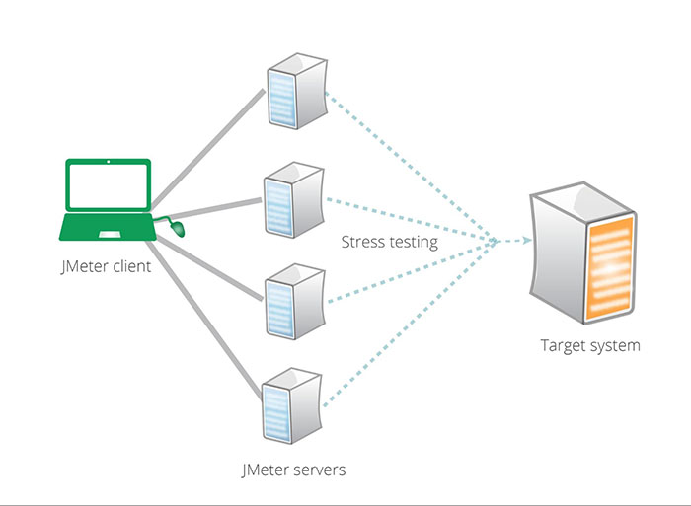

* + In the event that your JMeter client machine is unable to run with a large users (more than 5000 users), to simulate enough users to stress your server or is limited at network level, we can set up many Jmeter servers to run remotely from a single JMeter client. By running JMeter remotely, you can replicate a test across many computers and thus simulate a larger load on the Target system. One instance of the JMeter client can control any number of remote JMeter instances, and collect all the data from them. This offers the following features:
    - Saving of test samples to the local machine (Jmeter Client machine)
    - Management of multiple JMeter servers from a single Jmeter Client machine
    - No need to copy the test plan to each server - the client sends it to all the servers

(Note: The same test plan is run by all the servers. JMeter does not distribute the load between servers, each runs the full test plan. So if you set 1000 Threads and have 4 JMeter server, you end up injecting 4000 Threads.)

* Step 0: Configure the client and servers
  + Make sure that Jmeter client and Jmeter servers computers :
    - are running exactly the same version of JMeter.
    - are using the same version of Java on all systems. Using different versions of Java may work but is discouraged.
  + If the test uses any data files such as csv file, note that these are not sent across by the client so make sure that these are available in the appropriate directory on each server. You can also use HTTP Simple Table Server to keep the data in Jmeter Client and each Server will get data from this table.
* Set Up And Run Remote
  + Step 1: Start the servers
    - To run JMeter in remote node, start the JMeter server component on all machines you wish to run on by running the JMETER_HOME/bin/jmeter-server (unix) or JMETER_HOME/bin/jmeter-server.bat (windows) script.

(Note that there can only be one JMeter server on each machine.)

* + Step 2: Add the server IP to your client's Properties File
    - Edit the properties file on the JMeter Client machine. In JMETER_HOME/bin/jmeter.properties, find the property named, "remote_hosts", and add the value of your running JMeter server's IP address. Multiple such servers can be added, comma-delimited.
  + Step 3a: Start the JMeter Client from a GUI client to check configuration
    - Now you are ready to start the controlling JMeter client. For MS-Windows, start the client with the script "bin/jmeter.bat". For UNIX, use the script "bin/jmeter". You will notice that the Run menu contains two new sub-menus: "Remote Start" and "Remote Stop" (see figure 1). These menus contain the client that you set in the properties file. Use the remote start and stop instead of the normal JMeter start and stop menu items.

[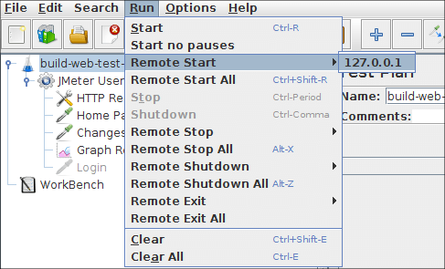](https://jmeter.apache.org/images/screenshots/remote/run-menu00.png)

* + Step 3b: Start the JMeter from a non-GUI Client
    - GUI mode should only be used for debugging, as a better alternative, you should start the test on remote server(s) from a non-GUI (command-line) client. The command to do this is:

jmeter -n -t script.jmx -r

* + - or

jmeter -n -t script.jmx -R server1,server2,…

* + - Other flags that may be useful: -X to Exit remote servers at the end of the test.
    - The command-line client will exit when all the remote servers have stopped.
* What Is Plugins Manager?
  + The idea of JMeter Plugins Manager is simple: instead of installing various plugins manually, it will do it for you through nice UI. No need to mess with JARs anymore. Install Plugins Manager once and it will do it all for you: installing, upgrading and uninstalling.
  + The plugins it manages include usual plugins from JMeter-Plugins.org, various third-party plugins and even core JMeter plugins.
* Install and using Plugins Manager
  + Download Plugins Manager from: <https://jmeter-plugins.org/wiki/PluginsManager/>
  + Download the Plugins Manager JAR file and put it into JMeter's lib/ext directory. Then start JMeter and go to "Options" menu to access the Plugins Manager.

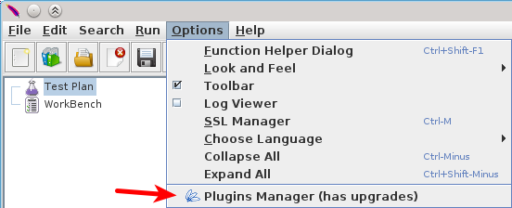

* The label on the menu item will say "has upgrades" in case any of your installed plugins have upgrades for it.
* Clicking on menu item will bring up the plugins manager dialog:

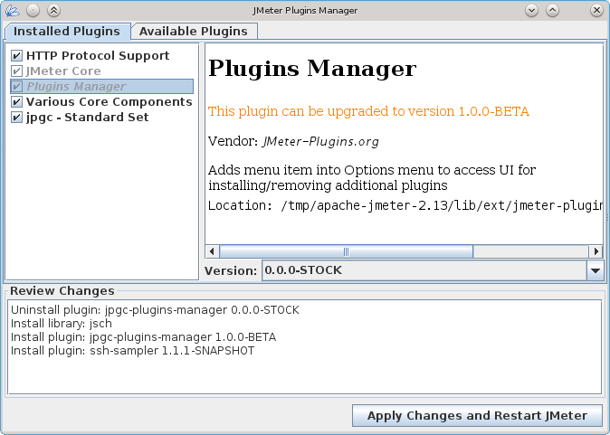

* The dialog has three tabs, "Review Changes" area and "Apply" button. Removing ticks from plugins on "Installed" tab will uninstall them. Setting ticks on "Available" tab will install the plugin.
* The plugins that have upgrades will show in the list with italic font. Choose the new version you want to install for them from "Version" drop-down. By default, all upgradable plugins are selected for upgrade and listed on "Upgrades" tab.
* The "Review Changes" pane is important, it lists all the changes that supposed to be done after you click "Apply" button. Sometimes plugins have dependencies from each other, so there might be additional plugins uninstalled. There is no hurry for important business, so review the changes prior to applying it.
* Right mouse click over checkbox lists opens "Toggle All" option, which takes some time to toggle all items in the list.
* User Define Variables: is a place that you can set Variables for using in node under this setting. For example, to log in with different username and password for each Thread group, we can set up a User Define Variable in each Thread Group.